|  |  |  |  |  |  |  |  |
| --- | --- | --- | --- | --- | --- | --- | --- |
| **Date:** | **22-05-20** | | | | **Name:** | **SAHANA C** | |
| **Sem & Sec** | **VI B** | | | | **USN:** | **4AL17CS116** | |
| **Online Test Summary** | | | | | | | |
| **Subject** | | **OS IA Test** | | | | | |
| **Max. Marks** | | **30** | | **Score** | | **30** | |
| **Certification Course Summary** | | | | | | | |
| **Course** | **Ethical Hacking** | | | | | | |
| **Coding Challenges**   1. Write a python program to print all the prime numbers in the interval 2. Write python program to find sum of arrays | | | | | | | |
| **Certificate Provider** | | | **Great learning** | **Duration** | | | **6 days** |
| **Status:Completed** | | | | | | | |
| **Uploaded the report in Github** | | | | **Yes** | | | |
| **If yes Repository name** | | | | **https://github.com/sahanasanu/Daliy-status** | | | |
| **Uploaded the report in slack** | | | | **Yes** | | | |

**DAILY ONLINE ACTIVITIES SUMMARY**

**Online Certification Details**

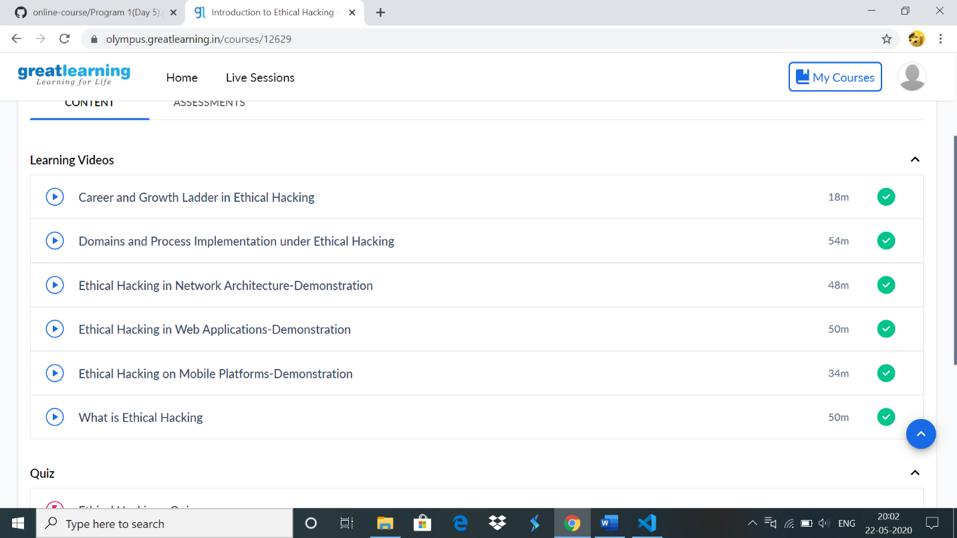

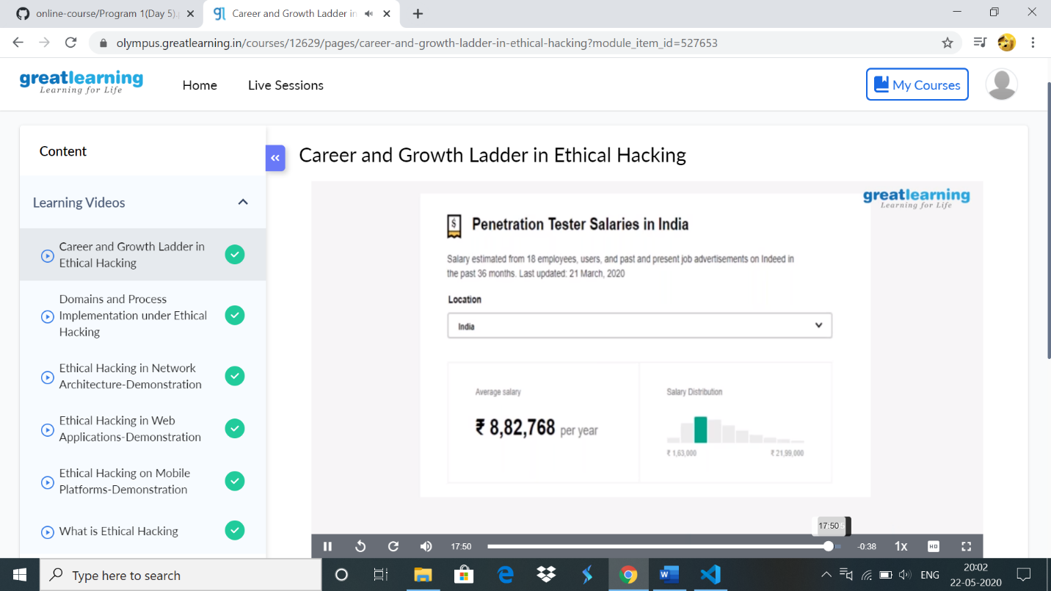

Codding challenges:

1. Write a python program to print all the prime numbers in the interval

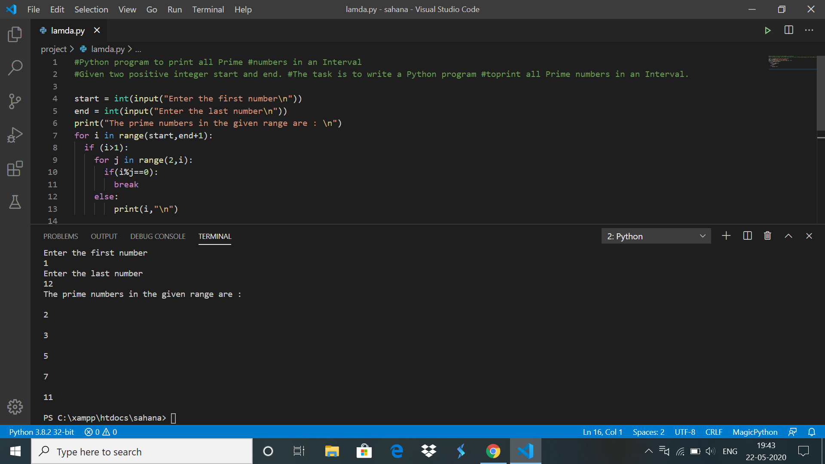

2) Write python program to find sum of arrays

